14.21: The buoyant force must be equal to the total weight; 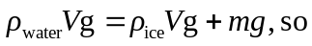

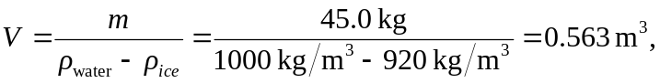

or 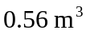 to two figures.

